Container and Basic Execution Service Model in OGSATM Grid

Status of This Document
This document provides information to the Grid community on modeling a Container and a Basic Execution Service. It does not define any standards or technical recommendations. Distribution is unlimited.

Copyright Notice
Copyright © Open Grid Forum (2006-2007). All Rights Reserved.

Trademarks
OGSA is a trademark of the Open Grid Forum.

Abstract
This memo provides information to the Grid community on the information modeling of containers and a basic execution service for OGSA (Open Grid Services Architecture). It defines the proposed container element and basic execution service element for inclusion in DMTF’s Common Information Model. Specific containers, such as the OGSA Basic Execution Services container, should be defined as profiles and/or extension elements of container. Operations specific to a service should not be part of the container. Distribution is unlimited.
Contents

1. Overview 3
2. The Container Model 3
3. The Basic Execution Service Model 4
4. UML 4
5. Discussion of the Model Elements 5
5.1 New Classes 5
5.2 New Associations 6
5.3 Properties Added to Existing Classes 6
5.4 Methods Added to Existing Classes 6
6. Managed Object Format (MOF) 6
7. Security Considerations 9
8. Contributions 9
9. Intellectual Property Statement 10
10. Disclaimer 10
11. Full Copyright Notice 10
12. References 10

Overview
The Container Model describes the managed objects and their relationships for defining the execution environment for activities in a grid. The Basic Execution Service model defines the service. This service can act on the container model. The CIMv2.15 final schema [CIM2.15final] is the foundation for the development of these two models. It is expected that these two models will be folded into CIMv2.16 preliminary [CIM2.16prelim].
In this document we provide the container model in UML, DMTF CIM Managed Object Format (MOF). DMTF provides their XML representation via automatic conversion tool (MOF to CIM-XML, via CIM DTD as well as WS-CIM).

The Container Model
OGSA defines a container as any environment in which a task can execute. A container may be, for example, a queuing service, a Unix host, a J2EE environment, or a collection of containers (a façade or a virtual organization of job containers). A container may contain zero or more containers. A container has resource properties that describe both static and dynamic information, e.g. OS version, types of executables allowed, policies, security, load, QoS information. A container may implement some subset of the manageability interfaces such as Web Services Distributed Management (WSDM) or WS-Management. The container has various relationships to other resources. The container may use various services such as reservation services, logging services, information services, job management services, and provisioning services.
A single new class, Container, is defined as a subclass of the Collection class. This class captures the basic semantics of containers. It may be necessary to subclass this Container class to express all the semantics of a specific container, for example, to add an attribute or operation that is specific to that container. A service may act on a container.
The Container acts as an aggregator of the managed properties necessary for the use of the container through its various relationships with the ManagedElement class. This means that a very large number of attributes may be associated with a container. For ease of implementation, usability, extensibility, and interoperability, the details of what is contained in the container should be defined by a profile. The Basic Execution Service (BES) container aggregates and exposes attributes needed to make scheduling decisions. Although there are few attributes of a container, for extensibility it is easier to define a profile for implementation.
The class added to CIMv2.16 experimental in support of the Container work is marked as ‘Experimental’ in the CIM MOF and as {E} in the UML diagram and appears in bold font for easier identification.
The model elements are discussed in a bit more detail in Section 5 following the presentation of the UML in Section 4. The Managed Object Format (MOF) description is given in Section 6. (MOF is a textual rendering of UML, defined in the CIM Specification [CIMspec] published by the DMTF).
Note: It is expected that additional CIM classes, attributes, and methods may be defined and need to be added to CIM as the specific container profile work progresses. These will be documented in similar fashion to the Container class in a separate informational document.

The Basic Execution Service Model
The Basic Execution Service is a service to which clients can send requests to initiate, monitor, and manage computational activities. Operationally, it uses information in a container and operates on activities within that container. This service is a subclass of the class CIM_Service.
The class added to CIMv2.16 experimental in support of this service is marked as ‘Experimental’ in the CIM MOF and as {E} in the UML diagram and appears in bold font for easier identification.
The model elements are discussed in a bit more detail in Section 5 following the presentation of the UML in Section 4. The Managed Object Format (MOF) description is given in Section 6. (MOF is a textual rendering of UML, defined in the CIM Specification [CIMspec] published by the DMTF).

UML
The figure below depicts the classes and properties of the container model. The new class with its attributes and methods are highlighted in red bold.

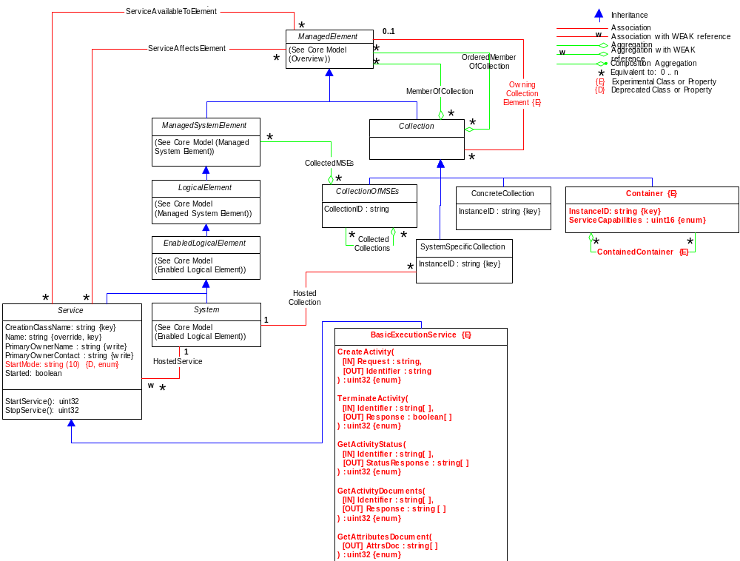
Figure 1. Container and Basic Execution Service Model

Discussion of the Model Elements
This section describes the classes, associations, properties, and methods proposed to be added to CIM v2.16 experimental in support of a container model and a basic execution service model. Background material as well as details (inputs, output, formats) of the basic execution service operations can be found in the Open Grid Forum document ‘Basic Execution Service’, GFD.xxx [BES].

New Classes

Container
The Container class inherits from the CIM_Collection class. It is a concrete class meaning that it is instantiable without further subclassing (although it certainly may be subclassed). It is a collection which defines an environment in which a task can execute A container may, for example, be a queuing service, a Unix host, a J2EE environment, or a collection of containers (a façade or a virtual organization of job containers). A container may contain zero or more containers. A container has resource properties that describe both static and dynamic information, e.g. OS version, types of executables allowed, policies, security, load, QoS information. A container may implement some subset of manageability interfaces such as Web Services Distributed Management (WSDM) or WS-Management. The container has various relationships to other resources. The container uses various services such as reservation services, logging services, information services, job management services, and provisioning services. Because this container class serves as an aggregator of other classes (attributes and methods) and can aggregate any ManagedElement (all classes in CIM are ManagedElements), the contents of a specific container are best described by a profile. So, the aggregated attributes represent advertised capabilities for the execution environment. These attributes may be for a single node, a cluster (homogeneous or heterogeneous) of nodes, or any number of back-end (end-node) resources no matter how disjoint, different, or geographically separated.
Contents:
- InstanceID (required)
Within the scope of the instantiating Namespace, InstanceID opaquely and uniquely identifies an instance of this class. Although CIM defines a preferred composition for InstanceID, other compositions are allowed, e.g. URI, EPR, that are opaque and uniquely identify an instance of this class.
- ServiceCapabilities
An enumerated attribute that defines the current general capabilities of the container, e.g. available to accept new activities.

Basic Execution Service
The grid Basic Execution service inherits from the CIM_Service class. The Basic Execution service is related to Container through several existing associations with ManagedElement: (1) ServiceAvailToElement – the Basic Execution service is available within the Container, and (2) ServiceAffectsElement – the Basic Execution service uses resources within the container and hence those resources may affect performance, throughput, availability, etc. The StartService and StopService operations (inherited from CIM_Service) are used to move the container associated with this service into a state where it is open for requests and closed for requests, respectively. For example, within the context of the OGSA Basic Execution Services specification, this means the container can start accepting new activities, and the operation maps to ‘StartAcceptingNewActivities()’ interface and the container stops accepting new activities, and the operation maps to ‘StopAcceptingNewActivities()’ interface, respectively. The StartService and StopService operations sets the enumerated values of ServiceCapabilities attribute in the associated Container.
- CreateActivity
This operation adds requests to the container. For example, within the context of the OGSA Basic Execution Services specification, this means that a new activity is added to the container, and the operation maps to the ‘CreateActivity()’ interface.
- TerminateActivity
This operation requests that one or more items in the container be terminated. For example, within the context of the OGSA Basic Execution Services specification, this means that a new or existing activity in the container can be requested to be terminated, and the operation maps to the ‘TerminateActivities()’ interface.
- GetActivityStatus
This operation requests the status of one or more items in the container. For example, within the context of the OGSA Basic Execution Services specification, this means that the status of one or more activities within the container can be obtained, and the operation maps to the ‘GetActivityStatuses()’ interface.
- GetActivityDocuments
This operation requests activity document descriptions for a set of specified activities. These activity documents may be different from those initially passed to this basic execution service in the CreateActivity operation since this service may alter its contents to reflect policy or process within the service. For example, within the context of the OGSA Basic Execution Services specification, this means that the activity documents can be obtained, and the operation maps to the ‘GetActivityDocuments()’ interface.
- GetAttributesDocument
This operation requests a document containing the basic execution service management attributes within the associated container. For example, within the context of the OGSA Basic Execution Services specification, this means that the attributes within a container may be obtained, and the operation maps to the ‘GetAttributesDocument()’ interface.

New Associations
None.

Properties Added to Existing Classes
None.

Methods Added to Existing Classes
None.

Managed Object Format (MOF)
The schema is described in Managed Object Format, defined in [CIMspec].
The MOF below reflects the UML diagram in this document. It is included to provide the details and descriptions necessary to understand the UML.

//Copyright © 2007 DMTF. All rights reserved.
// ==================================================================
// CIM_Container
// ==================================================================
[Experimental, Version ( "2.16.0" ),
UMLPackagePath ( "CIM::Core::Collection" ), Description (
"A concrete version of Collection. This class represents a "
"collection of running entities and activities, e.g. services, "
"jobs. A Container may, for example, be a queuing service, "
"a Unix host, a J2EE environment, or a collection of "
"containers (a facade or a virtual organization of job "
"containers). A Container has properties that describe both "
"static and dynamic information, e.g. OS version, types of "
"executables allowed, policies, security, load, QoS "
"information. A Container may implement some subset of "
"manageability interfaces. The Container uses various services "
"such as reservation services, logging services, information "
"services, job management services, and provisioning services. "
"The Container acts as an aggregator if the managed properties "
"necesary for the use of the container through its various "
"relationships with the ManagedElement class. Specific "
"containers necessary for implementation and interoperability "
"should, in general, be defined by a profile instead of "
"subclassing. ")]
class CIM_Container : CIM_Collection {

[Key, Description (
"Within the scope of the instantiating Namespace, InstanceID "
"opaquely and uniquely identifies an instance of this class. "
"To ensure uniqueness within the NameSpace, the value of "
"InstanceID should be constructed using the following "
"'preferred' algorithm: \n"
"<OrgID>:<LocalID> \n"
"Where <OrgID> and <LocalID> are separated by a colon ':', "
"and where <OrgID> must include a unique name. It can be a "
"copyrighted, trademarked, or otherwise unique name that is "
"owned by the business entity that is creating or defining "
"the InstanceID. Or, it could be a registered ID that is "
"assigned to the business entity by a recognized global "
"authority. (This requirement is similar to the <Schema "
"Name>_<Class Name> structure of Schema class names.) In "
"addition, to ensure uniqueness <OrgID> must not contain a "
"colon (':'). When using this algorithm, the first colon to "
"appear in InstanceID must appear between <OrgID> and "
"<LocalID>. \n"
"\n"
"<LocalID> is chosen by the business entity and should not "
"be re-used to identify different underlying (real-world) "
"elements. If the above 'preferred' algorithm is not used, "
"the defining entity must ensure that the resulting "
"InstanceID is not re-used as any of the InstanceIDs "
"produced by this or other providers for the NameSpace of "
"this instance.")]
string InstanceID;

[Description (
"An enumerated integer that defines the current general "
"service capabilities of the container. "
),
ValueMap { "0", "1", "2", "3..4095", "4096..32767" },
Values { "Unknown", "Other", "Create Requests", "DMTF Reserved",
"Vendor Reserved" }]
uint16 ServiceCapabilities;

};

//Copyright © 2007 DMTF. All rights reserved.
// ==================================================================
// CIM_BasicExecutionService
// ==================================================================
[Experimental, Version ( "2.16.0" ),
UMLPackagePath ( "CIM::Core::Service" ), Description (
" The basic execution service (BES)is a service to which "
"clients can send requests to initiate, monitor, and manage "
"computational activities and access information about the "
"BES. ")]
class CIM_BasicExecutionService : CIM_Service {

[Description (
"This operation adds requests to the container. For "
"example, within the context of the OGSA Basic Execution "
"Services, this means that a new activity is added to the "
"container, and the operation maps to the CreateActivity() "
"interface. The return value should be 0 if the request was "
"successfully executed and some other value if an error "
"occurred."),
ValueMap { "0", "1", "2", "3", "4", "5", "6", "..",
"4096..32767", "32768..65535" },
Values { "Job Completed with No Error", "Not Supported",
"Unknown", "Not Authorized Fault",
"Not Accepting New Activities",
"Unsupported Feature Fault",
"Invalid Request Message Fault",
"DMTF Reserved", "Method Reserved", "Vendor Specific" }"),
MappingStrings
{ "MIF.OGF|GFD.xxx|CreateActivity.Faults" }]

uint32 CreateActivity(

[IN, Description (
"Describes a single request that is to be executed by the "
"container."),
MappingStrings
{ "MIF.OGF|GFD.xxx|CreateActivity.ActivityDocument",
"MIF.OGF|GFD.56|jsdl:JobDefinition" },]
string Request,

[IN ( false ), OUT, Description (
"Identifier associated with the requested execution."),
MappingStrings
{ "MIF.OGF|GFD.xxx|CreateActivity.Response",
{ "MIF.OASIS|WS-Addressing",
"MIF.OGF|GFD.56|jsdl:JobDefinition" },]
string Identifier);

[Description (
"This operation requests that one or more items in the "
"container be terminated. For example, within the context "
"of the OGSA Basic Execution Services, this means that a new "
"or existing activity in the container can be requested to "
"be terminated, and the operation maps to the "
"TerminateActivities() interface. The return value should "
"be 0 if the request was successfully executed and some "
"other value if an error
occurred."),
ValueMap { "0", "1", "2", "3", "..",
"4096..32767", "32768..65535" },
Values { "Job Completed with No Error", "Not Supported",
"Unknown", "Invalid Request Message Fault",
"DMTF Reserved", "Method Reserved", "Vendor Specific" }"),
MappingStrings
{ "MIF.OGF|GFD.xxx|TerminateActivities.Faults" }]

uint32 TerminateActivity(

[IN, Description (
"Identifies one or more items in the container that are "
"to be terminated."),
MappingStrings
{ "MIF.OGF|GFD.xxx|TerminateActivities.ActivityIdentifiers",
{ "MIF.OASIS|WS-Addressing" },]
string Request[],

[IN ( false ), OUT, Description (
"Boolean response value for each requested termination. "
"A value of TRUE indicates successful termination."),
MappingStrings
{ "MIF.OGF|GFD.xxx|TerminateActivities.Response" }]
boolean Response[]);

[Description (
"This operation requests the status of one or more items in "
"the container. For example, within the context "
"of the OGSA Basic Execution Services, this means that the "
"status of one or more activities within the container can "
"be obtained, and the operation maps to the "
"GetActivityStatuses() interface. The return value should "
"be 0 if the request was successfully executed and some "
"other value if an error
occurred."),
ValueMap { "0", "1", "2", "3", "..",
"4096..32767", "32768..65535" },
Values { "Job Completed with No Error", "Not Supported",
"Unknown", "Invalid Request Message Fault",
"DMTF Reserved", "Method Reserved", "Vendor Specific" }"),
MappingStrings
{ "MIF.OGF|GFD.xxx|GetActivityStatuses.Faults" }]
uint32 GetActivityStatus(

[IN, Description (
"Identifies one or more items in the container whose "
"status will be obtained be terminated."),
MappingStrings
{ "MIF.OGF|GFD.xxx|GetActivityStatuses.ActivityIdentifiers",
{ "MIF.OASIS|WS-Addressing" },]
string Identifier[],

[IN ( false ), OUT, Description (
"A response for each requested termination. "),
MappingStrings
{ "MIF.OGF|GFD.xxx|GetActivityStatuses.Response" }]
string StatusResponse[]);

[Description (
"This operation requests activity document descriptions "
"for a set of specified set of activities. These activity "
"documents may be different from those initially input in "
"the CreateActivity operation since this service may alter "
"its contents to reflect policy or process within the "
"service."),
ValueMap { "0", "1", "2", "3", "..",
"4096..32767", "32768..65535" },
Values { "Job Completed with No Error", "Not Supported",
"Unknown", "Invalid Request Message Fault",
"DMTF Reserved", "Method Reserved", "Vendor Specific" }"),
MappingStrings
{ "MIF.OGF|GFD.xxx|GetActivityDocuments.Faults" }]
uint32 GetActivityDocuments(

[IN, Description (
"Identifies one or more activities for which activity "
"documents are requested."),
MappingStrings
{ "MIF.OGF|GFD.xxx|GetActivityDocuments.ActivityIdentifiers",
{ "MIF.OASIS|WS-Addressing" },]
string Identifier[],

[IN ( false ), OUT, Description (
"A vector of activity document response elements."),
MappingStrings
{ "MIF.OGF|GFD.xxx|GetActivityDocuments.Response" }]
string Response[]);

[Description (
"This operation requests a document containing the basic "
"execution service management attributes."),
ValueMap { "0", "1", "2", "3", "..",
"4096..32767", "32768..65535" },
Values { "Job Completed with No Error", "Not Supported",
"Unknown", "Invalid Request Message Fault",
"DMTF Reserved", "Method Reserved", "Vendor Specific" }"),
MappingStrings
{ "MIF.OGF|GFD.xxx|GetAttributesDocument.Faults" }]
uint32 GetAttributesDocument(

[IN ( false ), OUT, Description (
"A XML document containing the various attributes within "
"its associated container. "),
MappingStrings { "MIF.OGF|GFD.xxx|GetAttributesDocument.BESResourceAttributesDocument" }]
string AttrsDoc[]);

};

//Copyright © 2007 DMTF. All rights reserved.
// ==================================================================
// CIM_ContainedContainer
// ==================================================================
[Experimental, Association, Aggregation, Version ( "2.16.0" ),
UMLPackagePath ( "CIM::Core::Collection" ), Description (
"CIM_ContainedContainer is an aggregation association "
"representing that a Container can itself be contained "
"in a Container.")]
class CIM_ContainedContainer {

[Key, Aggregate, Description (
"The 'higher level' or parent element in the aggregation.")]
CIM_Container REF Collection;

[Key, Description (
"The 'collected' Collection of Containers.")]
CIM_Container REF CollectionInCollection;
};

Security Considerations
This specification defines the model and XML Schema for containers and a basic execution service. While the interactions of containers with its activities must be secured, the security details are outside the scope of this specification. Instead, it is assumed that security is addressed in specifications that define how this model and XML Schema are bound to specific communication protocols (such as [CIMOPS] or [OGSA]) and programming environments.

Contributions
The Author listed on the title page is committed to taking permanent stewardship for this document – receiving communication in the future and otherwise being responsive to its content. The contact information is provided below:

Ellen Stokes
IBM
11400 Burnet Rd
Austin, TX 78758
stokese@us.ibm.com
+1 512 778 5821

Other contributors include members of the OGSA and BES workgroups.

Intellectual Property Statement
The OGF takes no position regarding the validity or scope of any intellectual property or other rights that might be claimed to pertain to the implementation or use of the technology described in this document or the extent to which any license under such rights might or might not be available; neither does it represent that it has made any effort to identify any such rights. Copies of claims of rights made available for publication and any assurances of licenses to be made available, or the result of an attempt made to obtain a general license or permission for the use of such proprietary rights by implementers or users of this specification can be obtained from the OGF Secretariat.
The OGF invites any interested party to bring to its attention any copyrights, patents or patent applications, or other proprietary rights which may cover technology that may be required to practice this recommendation. Please address the information to the OGF Executive Director.

Disclaimer
This document and the information contained herein is provided on an “As Is” basis and the OGF disclaims all warranties, express or implied, including but not limited to any warranty that the use of the information herein will not infringe any rights or any implied warranties of merchantability or fitness for a particular purpose.

Full Copyright Notice
Copyright (C) Open Grid Forum (2006-2007). All Rights Reserved.
This document and translations of it may be copied and furnished to others, and derivative works that comment on or otherwise explain it or assist in its implementation may be prepared, copied, published and distributed, in whole or in part, without restriction of any kind, provided that the above copyright notice and this paragraph are included on all such copies and derivative works. However, this document itself may not be modified in any way, such as by removing the copyright notice or references to the OGF or other organizations, except as needed for the purpose of developing Grid Recommendations in which case the procedures for copyrights defined in the OGF Document process must be followed, or as required to translate it into languages other than English.
The limited permissions granted above are perpetual and will not be revoked by the OGF or its successors or assignees.

References
[CIM2.15final] DMTF CIM Schema, Version 2.15 Final, http://www.dmtf.org/standards/cim_schema_v215.php
[CIM2.16prelim] DMTF CIM Schema, Version 2.16 Experimental, http://www.dmtf.org/standards/cim_schema_v216.php
[CIMspec] DMTF, CIM Specification V2.3, http://www.dmtf.org/standards/documents/CIM/DSP0004.pdf
[BES] OGF, OGSA Basic Execution Service Specification, http://www.ogf.org/XXX.pdf (to be updated when spec is final)

www.oasis-open.org/committees/wsdm
www.dmtf.org/standards/wbem/wsman
This class is planned to be submitted to DMTF for inclusion in CIMv2.16 experimental.
Or in the future, management interfaces from the convergence of the WSDM and WS-MAN specifications.
See [BES] – BES factory port type attributes. The BR attributes are the advertised capabilities, and the BES attributes represent the aggregated statistics and characteristics of the nodes aggregated in the execution environment.

